

**SSR COLLEGE OF ARTS, COMMERCE & SCIENCE SILVASSA**

**(Affiliated to Savitribai Phule Pune University, NAAC Accredited with B+ Grade)**

**Submitted to the partial fulfillment of**

T.Y BBA(CA)

2022-2023

Project Work

“Life Insurance Company”

Guided By: Submitted By:

Mr. Vishal Langaliya 1. Sanyu Saju Mathew

2. Sonawane Sneha Sunil



**SSR COLLEGE OF ARTS, COMMERCE & SCIENCE SILVASSA**

**(Affiliated to Savitribai Phule Pune University, NAAC Accredited with B+ Grade)**

**Sayli, Silvassa-396230, D&N.H**

Department of Computer Application

**CERTIFICATE**

This is to certify that Mr. Sanyu Saju Mathew & Ms. Sonawane Sneha Sunil of

T.Y.B.B.A[Computer Application], Seat no: has

Completed their project work on the topic of **Life Insurance Company** in the

academic year 2022-2023.

**Project Guide H.O.D**

**Internal Examiner External Examiner**

**Seal of the College**

# ACKNOWLEDGEMENT

It is a great pleasure to acknowledge and express our deep sense of gratitude to **SSR College of ARTS COMMERCE & SCIENCE** for providing us the infrastructure to carry out the project.

I extremely grateful and remain indebted to our guide **Mr. Vishal** for being a source of inspiration and for her constant support in the Design, Implementation, and Evaluation of the project. I am thankful to him, for his constant constructive criticism and valuable suggestions, which benefited us a lot while developing the project on **Life Insurance Company**. He has been a constant source of inspiration and motivation which helped us to complete this project successfully.

I also extend my gratitude to our HOD, **Mr. Prakash Patil,** and other staff members of the department for their constant support for completing this project.

I would like to thank Savitribai Phule Pune University for providing us an opportunity to apply our knowledge and skills in a practical environment as a part of curriculum for **T.Y.B.B.A [Computer Application].**

Lastly but significantly, we express sincere gratitude to all our friends and fellow students at SSR College for their help and timely advice on various occasions during this project.

**Project Associates:**

* **Sanyu Saju Mathew**
* **Sonawane Sneha Sunil**

# ABSTRACT

The project titled **“Life Insurance Company”** is designed with HTML and CSS as the **front end** and PHP and SQL as the **back end**.

There will be different policies available in an Insurance company. This system is implemented to reduce manual work and enhances the accuracy of work, specially made for the **JEEVAN INSURANCE LTD**. This system manages and maintains the records of customers and their Policies. This desktop application has been made with a user-friendly interface. So that the admin can add and delete policies, agents and customers easily.

The system is built at the administrative end (also staff) and thus the only administrator is guaranteed access. This project report documents the process of designing and developing a desktop application to be used by an Insurance Company. The design form and the data report screenshot, advantages and limitations data dictionary, and future enhancement have been included.

INDEX

|  |  |  |
| --- | --- | --- |
| **S.NO.** | **TOPIC** | **PAGE.NO** |
| 1 | **INTRODUCTION**   1. Introduction to System 2. Scope of the System | 1 |
| 2 | **TOOL INFORMATION**   1. Front End Tool 2. Back End Tool | 3 |
| 3 | **ANALYSIS**   1. Feasibility Study 2. Fact-Finding Technique | 4 |
| 4 | **SOFTWARE AND HARDWARE REQUIREMENTS** | 7 |
| 5 | **SYSTEM DESIGN**   1. DFD 2. ER Diagram 3. Data Dictionary | 8 |
| 6 | **INPUT AND OUPUT DESIGN**   1. Screenshots | 20 |
| 7 | **REPORTS** | 40 |
| 8 | **ADVANTAGES AND LIMITATIONS** | 41 |
| 9 | **FUTURE ENHANCEMENT** | 42 |
| 10 | **BIBLIOGRAPHY** | 43 |

* 1. INTRODUCTION
     1. Introduction to the System

Online Insurance management system is a web application which is developed for tracking the details of the insurance policy, customer details and company details. This web site is an online insurance Analysis and information management system that provides easy access of information regarding the people and resources of insurance. This project is useful for any kind of insurance company to manage the insurance details, to sanctioned the insurance for customer, process the insurance policy details and all kind of insurance process through online. The Insurance management system is a complete solution for organizations, which need to manage insurance for their vehicles, equipment, buildings, and other resources. This insurance management system can efficiently manage the company, records, provides instant access and one that improves the productivity. In this online process the user enter into the website it will show details about insurance and its types, also it will show the details about different duration schemes to the corresponding insurance type or insurance policy. The main objective of the developed system is to allow admin users to register insured persons with their name, date of birth, residence address, family details and also policy details. In this process contains the user registration form which is used to apply for insurance policy through online. After giving registering all the insured persons, website should provide management facilities like delete unwanted persons’ data. A visitor with minimum knowledge of web browsing/surfing can access the site very easily. The developed system should allow admin users to register insured persons with their name, date of birth, residence address, medical history and also policy details. Then the admin send the permanent policy holder ID and password to the customer and also send status information about insurance policy to the corresponding policy holder. Due to dynamic nature of features, the members, Admin members should be able to understand the provided facilities. After registering all the insured persons, website should provide management facilities like delete unwanted persons’ data. And also should provide awareness to the visitors about micro insurance through articles. If the policyholder wants to view the information about their own policy details, he/she login to policy status page by using the policy holder ID and password already given by the insurance company and views their details and also give feedback to the insurance company. Online help documentation will be provided to help the users and visitors in using the facilities.

## Scope of the System

The application deals with creating an online Insurance Company management system that will automate major financial operations such as Registering customers adding policies, viewing customer details, etc,

Scopes that have been considered during the development of the project are as follows:

1. User Friendly.
2. Easily Upgradable.
3. Data Retrieval, Updating, Insertion, and Deletion.
4. System Consistency.
5. Allowing Keyboard Inputs.
6. Taking care of Computing time.
7. Easy Database Handling.

# TOOL INFORMATION

## Front-End Tool

The following frontend tools were used in the development of the project:

1. **Visual Studio Code:** Visual Studio Code is a code editor redefined and optimized for building and debugging modern web and cloud applications.
2. **HTML:** HTML, or Hypertext Markup Language, is a markup language for the web that defines the structure of web pages.
3. **CSS:** CSS describes how HTML elements are to be displayed on the screen, on paper, or in other media. CSS saves a lot of work. It can control the layout of multiple web pages all at once
4. **Google Fonts:** Making the web more beautiful, fast, and open through great typography.

## Back End Tool

The following backend tools were used in the development of the project:

1. **Visual Studio Code:** Visual Studio Code is a code editor redefined and optimized for building and debugging modern web and cloud applications.
2. **phpMyAdmin:** phpMyAdmin is a tool written in PHP, intended to handle the administration of MySQL over the Web.

# ANALYSIS

## Feasibility Study

The objective of the feasibility study is to solve the problem and to acquire the ease of its scope. Feasibility means practicable. The feasibility analysis focuses on the fact that whether the project will be accepted or not. If the feasibility analysis confirms that the project is feasible, it can be taken up for development. In the preliminary investigation, we found that project feasible.

Types of Feasibility

1. Operational Feasibility:

Operational feasibility makes a mark on whether the project can be done with the full requirements that the clients provide or not. Includes following:

* 1. Analyzing all requirements.
  2. Can be done in a given period or not.

1. Technical Feasibility:

Technical feasibility takes into account the technical aspect of the project including the following:

* 1. Whether the project can be implemented with the existing technology or not.
  2. Whether the project is technically compatible or not.

1. Economic Feasibility:

It determines whether the required software is capable of generating financial gains for an organization. It involves the cost incurred on the software development team’s estimated hardware cost and the cost of performing a feasibility study.

Studying the feasibility of the project, the project can be implemented within the given period and with the existing or specified technology. Hence, we can conclude that this project is feasible.

## Fact-Finding Technique

To study a system the analyst needs to collect facts and all relevant information. The facts when expressed in the quantitative form are termed data. The success of any project is dependent upon the accuracy of available data. Accurate information can be collected with help of certain methods/techniques. These specific methods for finding information about the system are termed fact-finding techniques Interviews, Questionnaires, Record views, and Observation are the different fact-gathering techniques used by the analyst. The analyst may use more than one technique for investigation.

### INTERVIEW:

This method is used to collect information from groups of individuals. The analyst selects the people who are related to the system for the interview. In this method, the analyst sits face-to-face with the people and records their responses. The interviewer must plan the type of questions he/she is going to ask and should be ready to answer any type of question. He should also choose a suitable place and time which will be comfortable for the respondent.

The information collected is quite accurate and reliable as the interviewer can clear and cross-check the doubts themselves. This method also helps gap the areas of misunderstanding and helps to discuss future problems. A structured interview is more formal where fixed questions are asked, and specific information is collected whereas an unstructured interview is more or less like a casual conversation wherein depth areas topics are covered and other information apart from the topic may also be obtained.

### RECORD VIEW:

The information related to the system is published in the sources like newspapers, magazines, journals, documents, etc. This record review helps the analyst to get valuable information about the system and the organization.

### OBSERVATION:

Unlike the other fact-gathering techniques, in this method the analyst himself visits the organization, he observes and understands the flow of the documents, the working of the existing system, the users of the system, etc. For this method to be adopted, it takes an analyst to perform this job as he knows which points should be noticed and highlighted. The analyst may observe unwanted things as well as simply cause a delay in the development of the new system.

### QUESTIONNAIRES:

Questionnaires are a research instrument that can be applied to fact-finding in system development projects. It is an economical way of gathering data from a large number of people.

# SOFTWARE AND HARDWARE REQUIREMENT

## Software Requirement

Operating system:

Windows 7 or higher versions.

Application Softwares:

* + - * Text Editor: Notepad, Visual Studio Code, Sublime, Atom, etc.
      * PHP editor: DSV PHP Editor, Notepad++, etc.
      * Web browsers: Microsoft Edge, Mozilla, Google Chrome, Opera, etc.
      * XAMPP.
      * MySQL Server(backend).

## Hardware Requirement:

To run the application software of the system on the computer, the minimum hardware configuration required is as below:

* + - * 1.7 GHz Pentium processor or other compatible
      * Intel chipset motherboard
      * 256 MB DDR-RAM
      * Color Monitor or LCD
      * Keyboard
      * Mouse

# SYSTEM DESIGNS

## Data Flow Diagram (DFD)

The data flow diagrams are pictorial or graphical representations of the system study. The data flow covers all the processes and data storage areas, which take place during any transaction in the system. The data flow diagrams are functionally into context-level, zero-level diagrams.

The following Data flow diagrams are based on ‘Gane-Sarson Notations’

1. **Process:** Here flow of data is transformed.
2. **External Entity:** A source or destination of data, which is external to the system.
3. **A Data Flow:** It is a packet of data. It may be in the form of a document, letter, etc.
4. **Data storage:** Any storage of data but with no reference to the physical memory 

Level 1 DFD

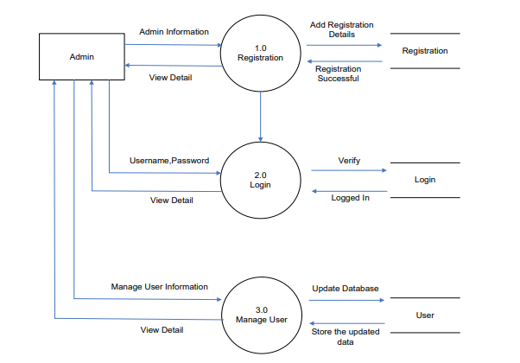

Level 2 DFD

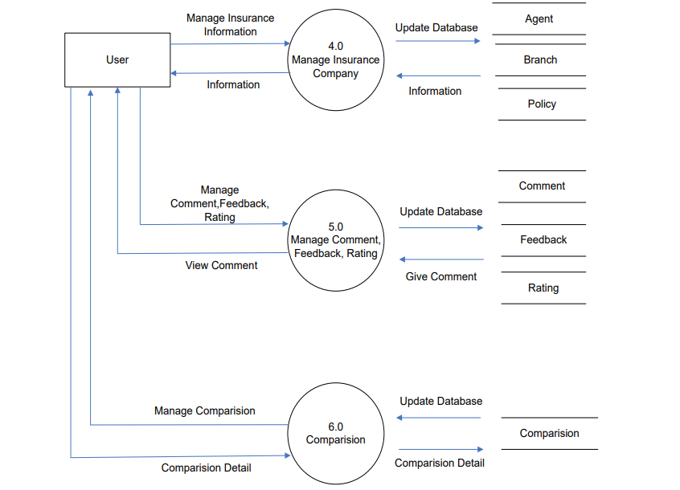

# USE CASE DIAGRAMS

## Use Case Diagram: Visitor and Facilities

**Public Pages**

Visitor

(Unregistered User)

## 6.2 Use Case Diagram: Online Registered Members and Facilities

Public Pages

**Secured Pages**

Content Admin

(Data Managing User)

## Entity Relationship (Er) Diagram

The Entity Relationship (ER) Diagram is a type of flowchart that illustrates how “entities” such as people, objects, or concepts relate to each other within a system.

ER Diagrams are most often used to design or debug relational databases in the fields of software engineering, business information systems, education, and research. Also known as ERDs or ER Models, they use a defined set of symbols such as rectangles, diamonds, ovals,s, and connecting lines to depict the interconnectedness of entities, relationship, ps, and their attributes.

1. **Entity:** Here flow of data is transformed. A definable thing—such as a person, object, concept, or event—that can have data stored about it.
2. **Relationship:** How entities act upon each other or are associated with each other.
3. **Attribute** A property or characteristic of an entity.

ER diagram:

**Insured Person’s details diagram**

Insured Person

Personal details

Has

1

1

Residence History

Has

n

1

Relationship Status

Has

n

1

Contact History

Has

* + - 1. **Insured Person – Personal details relation**

Insured Person

Personal details

Has

1

1

UML Diagram

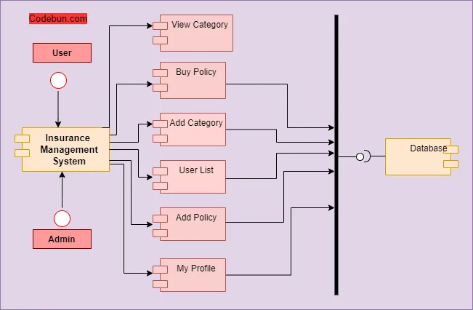

Sequence diagram

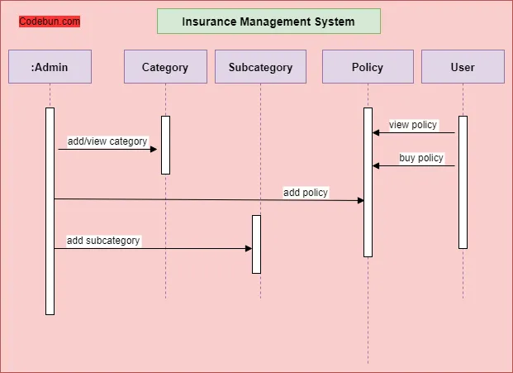

## Data Dictionary

A data dictionary is a repository that contains descriptions of all the data objects consumed by the software. It is a list of names used by the system alphabetically as well as the name, the dictionary should include a description of the named entity and, if the name represents a composite object, there may be a description of the named entity. Other information such as the date of creation, creator, and representation.

An entity may also include depending on the type of module, which is being developed.

The data dictionary software can check for name uniqueness and tell requirements for analyst duplication. It serves as a store of organizational information that can link analysis, design, implementation, and evolution.

As the system is developed, information is taken to inform the development. New information is added to it. All information about the entity is in one place.

Agent

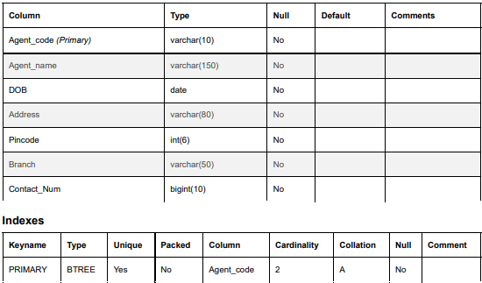

Customer

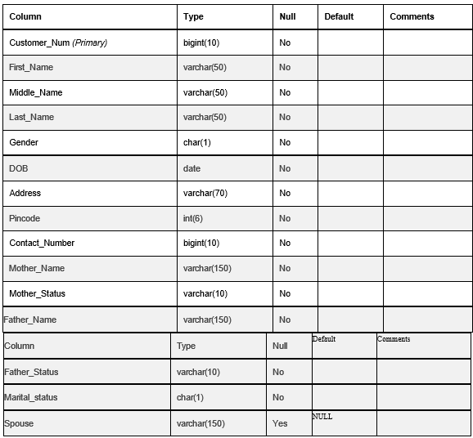

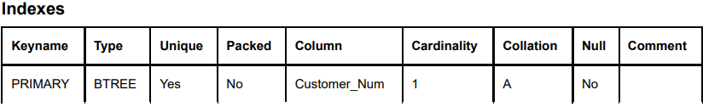

**enquiries**

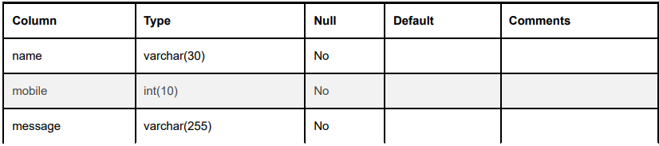

policy_data

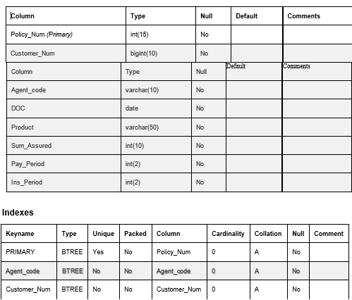

Premium

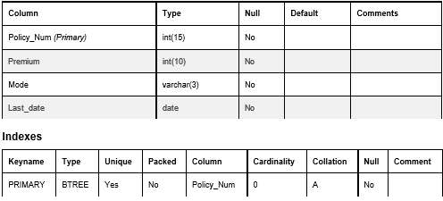

unpaid_premium

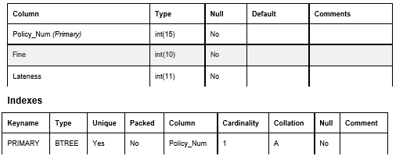

Screen Shots

User Side

Home Page

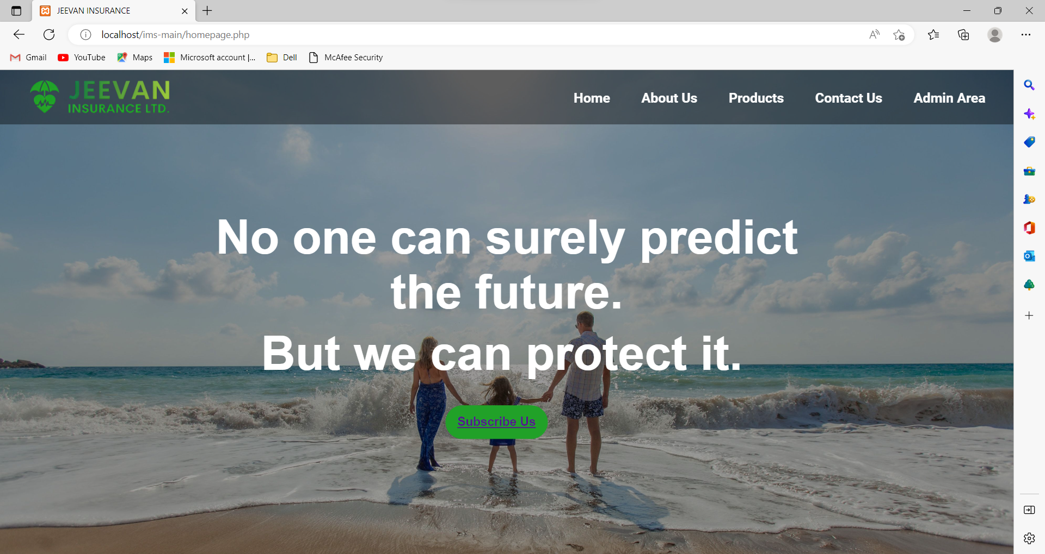

About Us

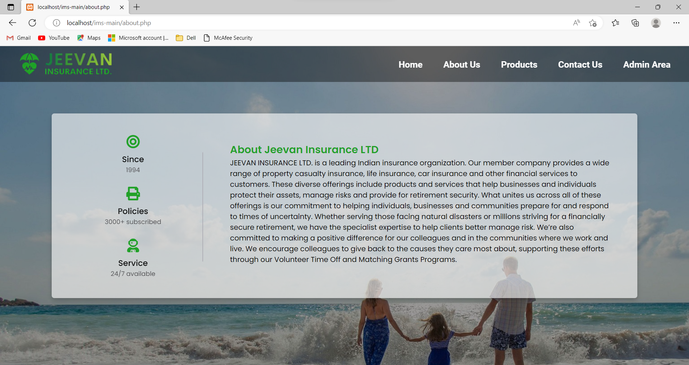

Products

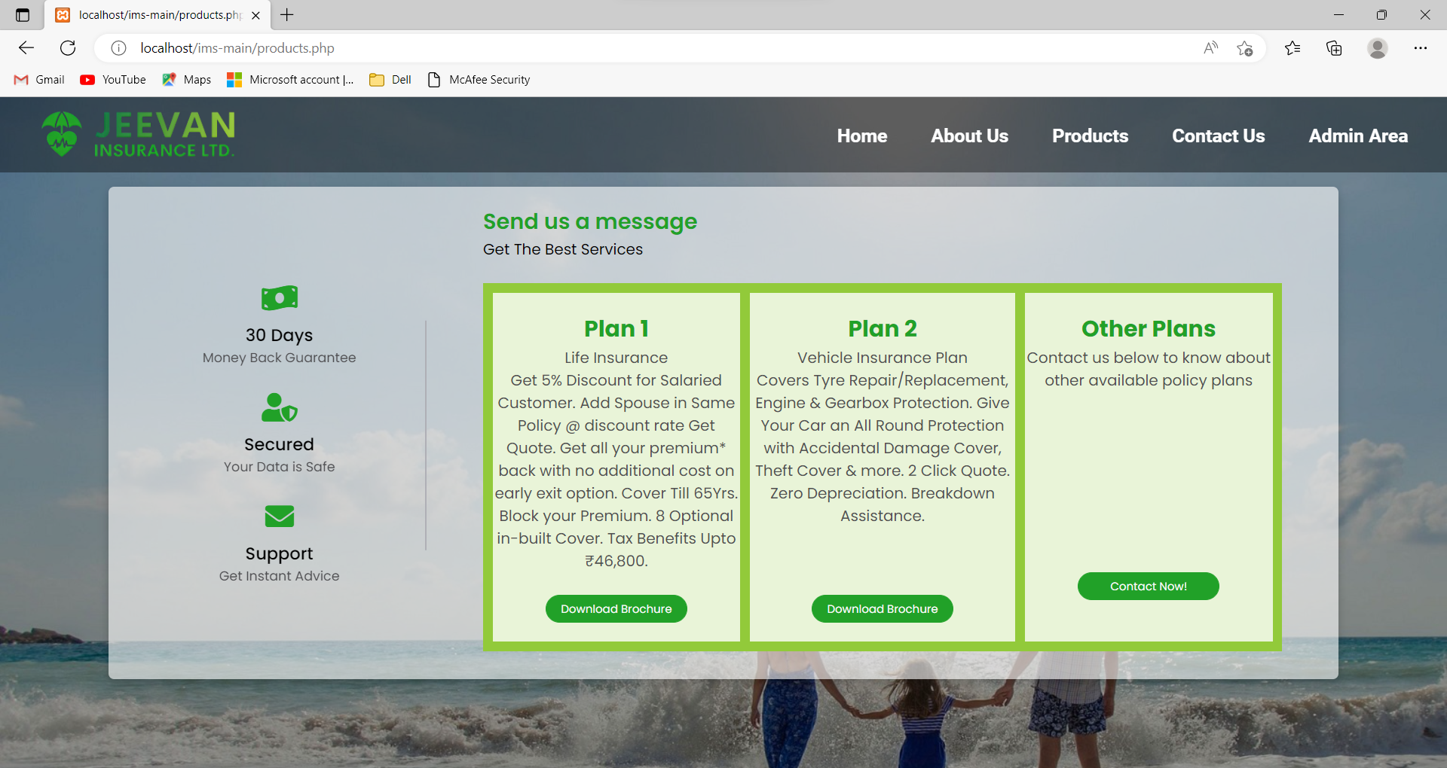

Contact Us

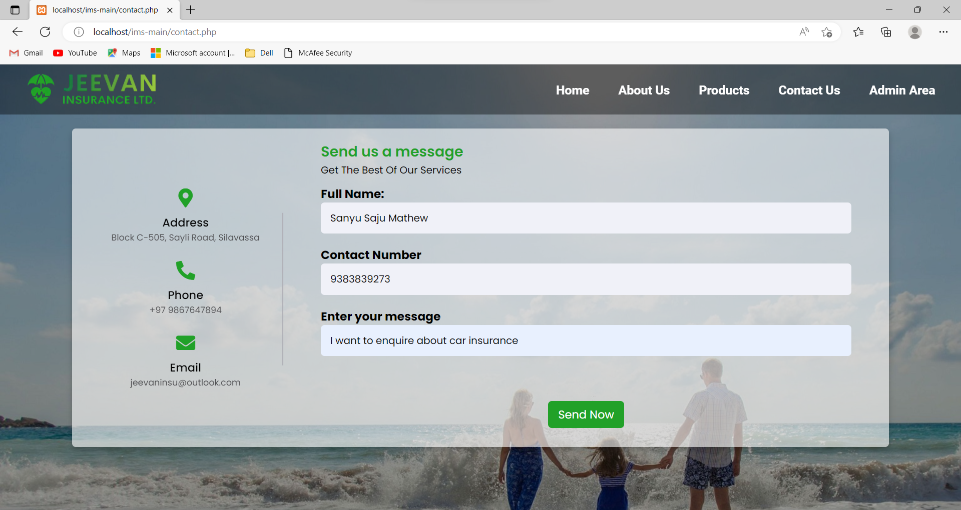

Admin Side

Admin Login

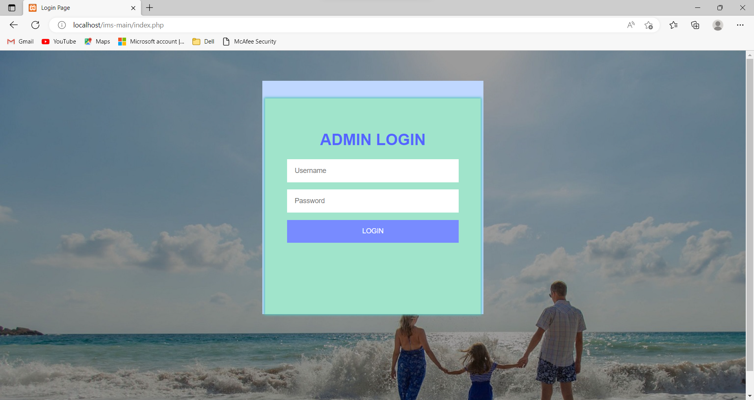

Admin Homepage

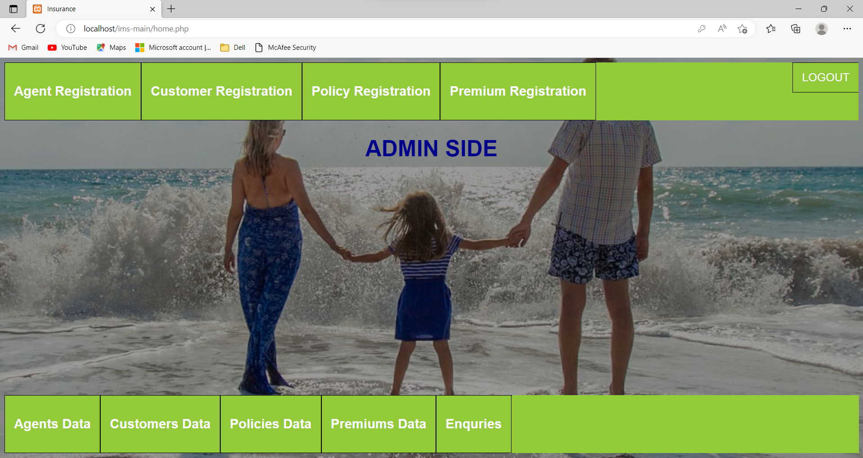

Agent Registration Page

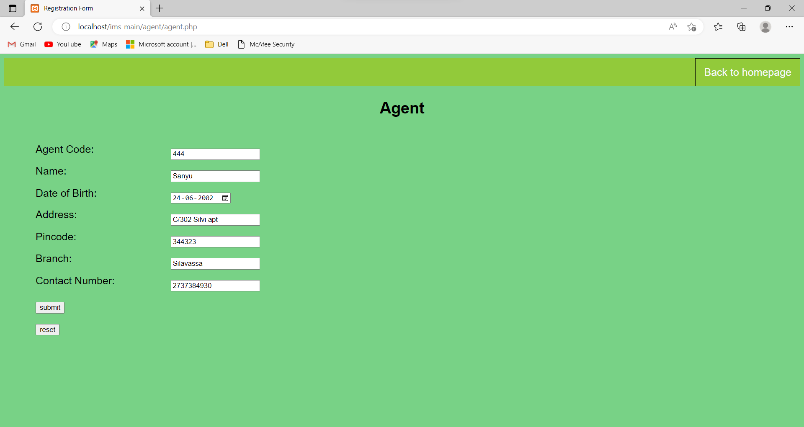

Agents Data

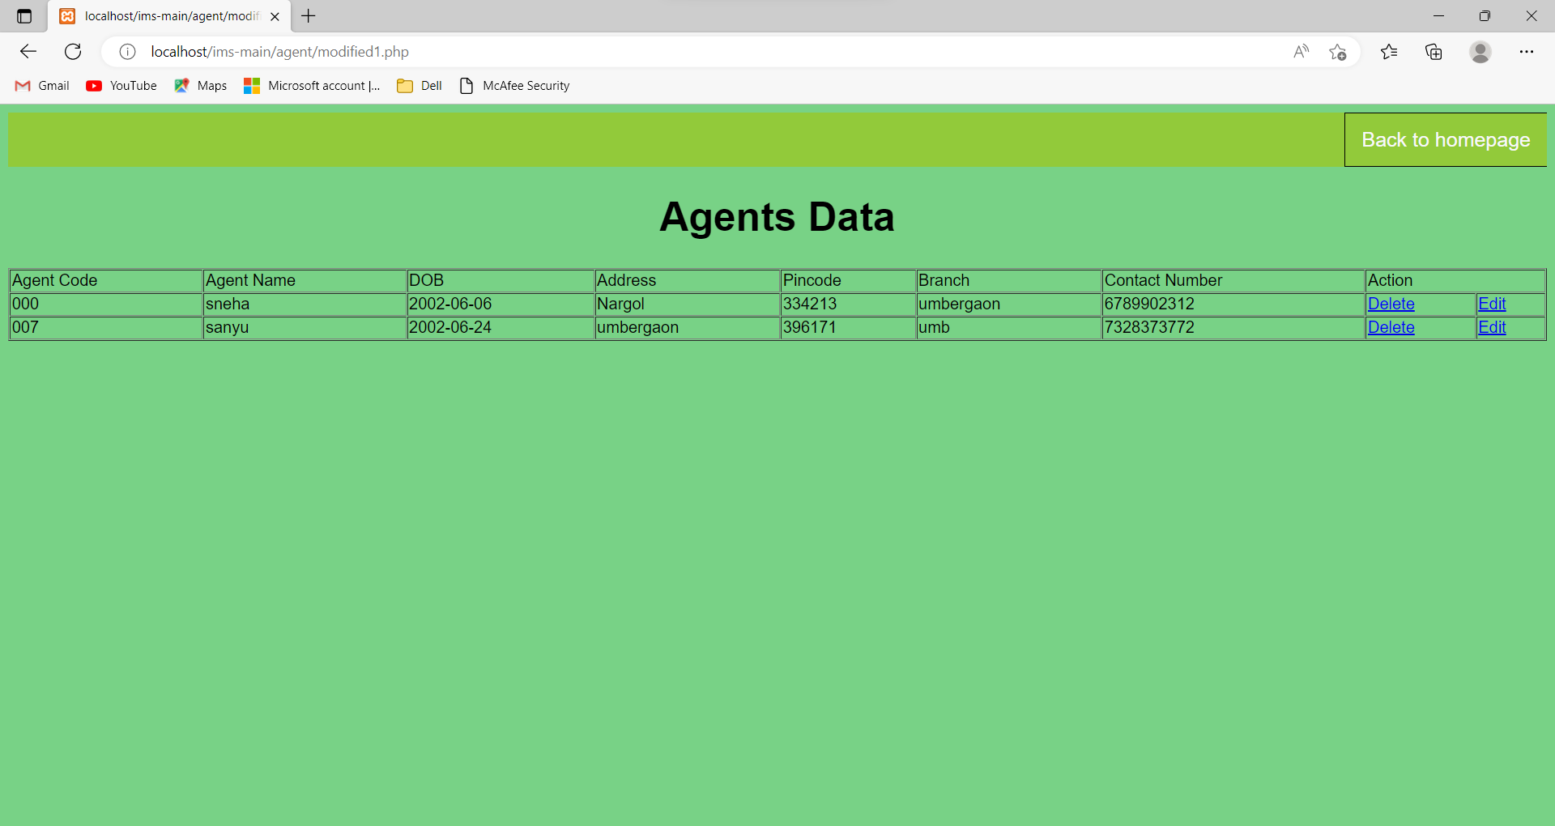

Customer Registration

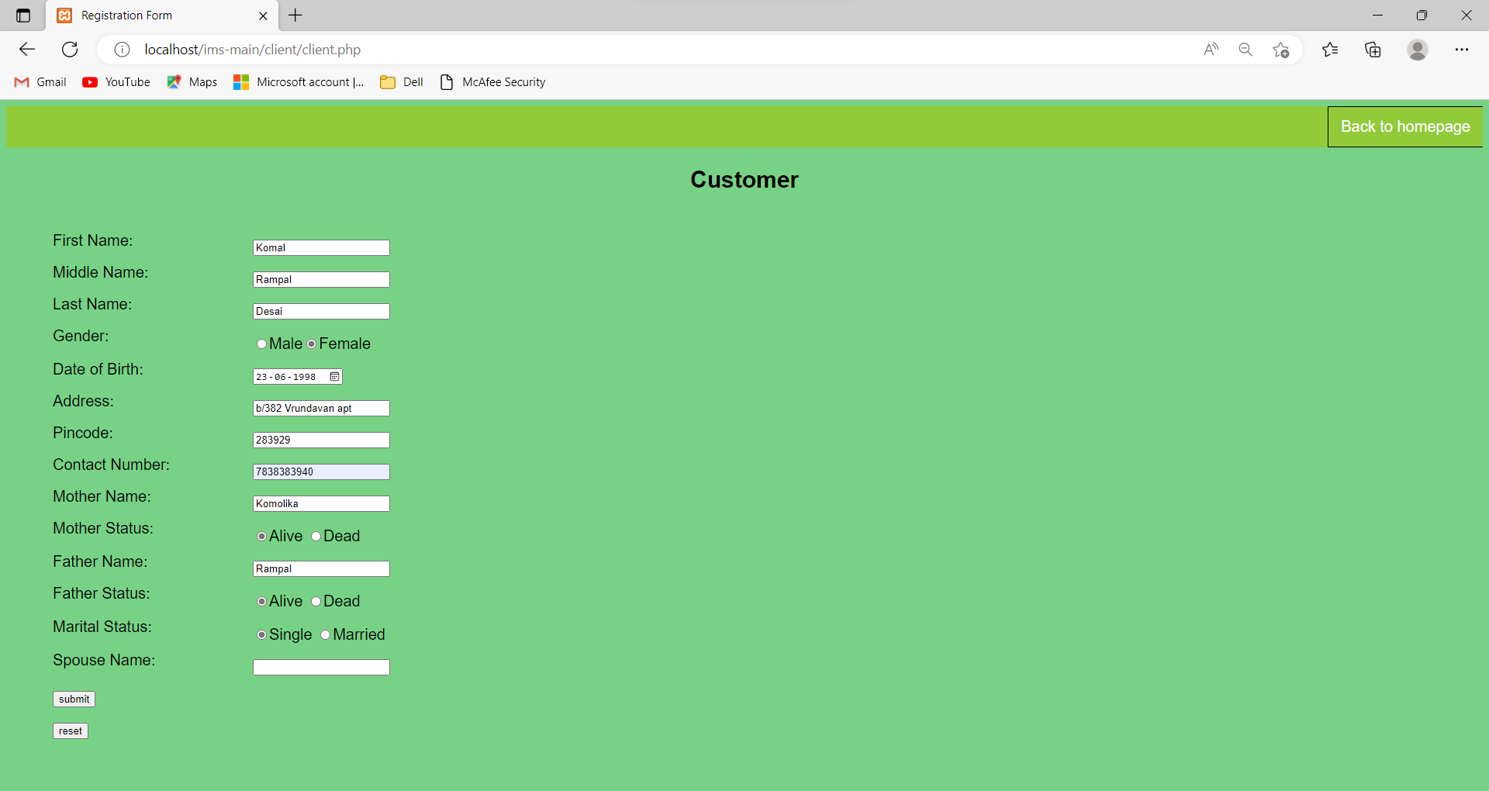

Customers Data

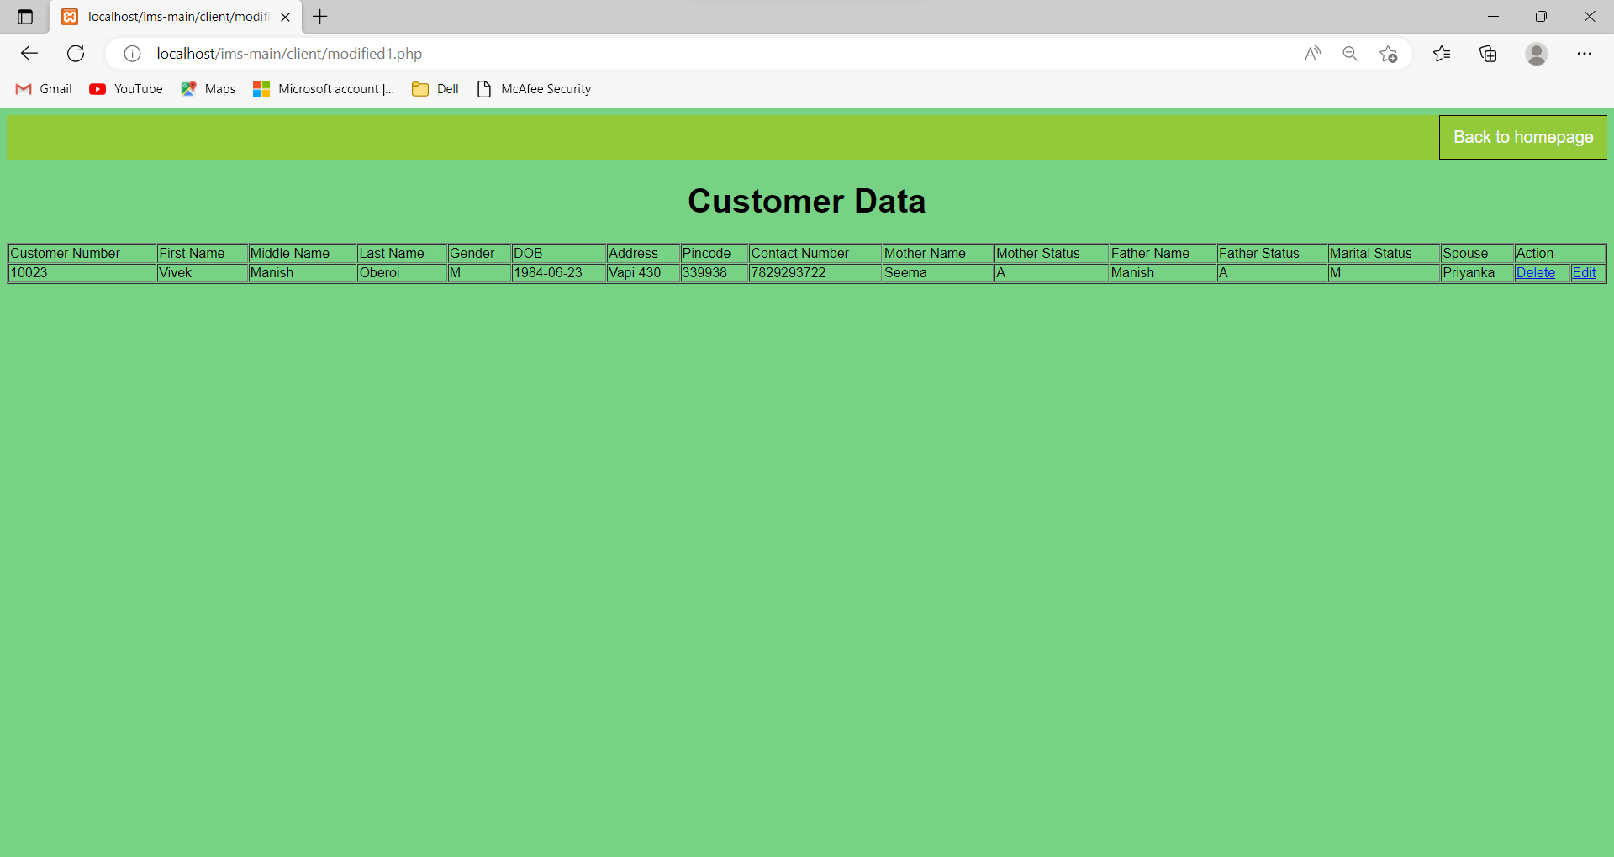

Policy Registration

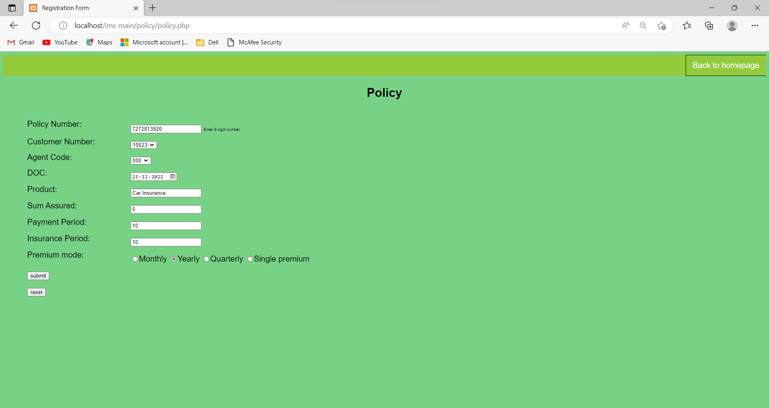

Policies Data

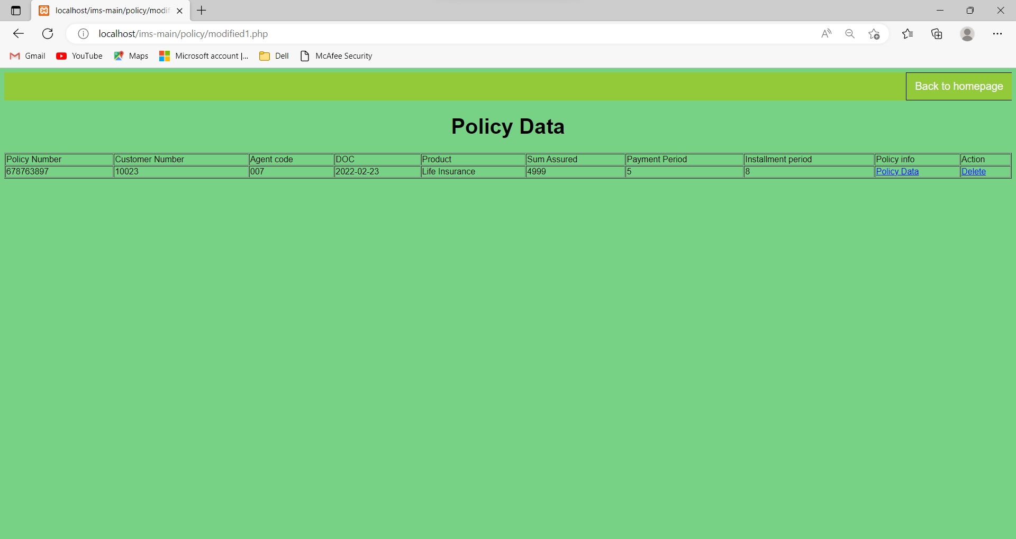

Policy Receipt/Info

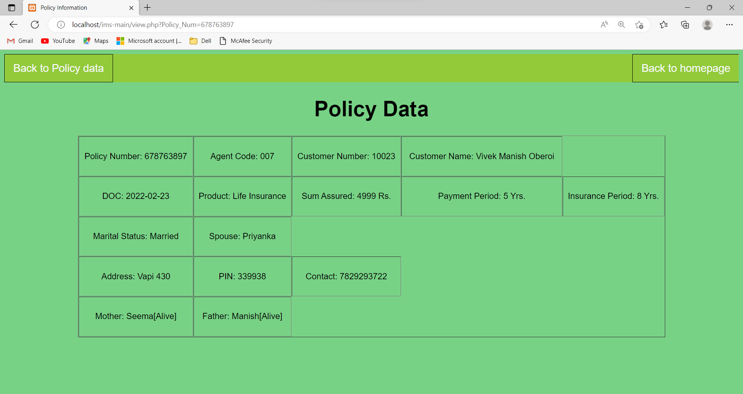

Premium Registration

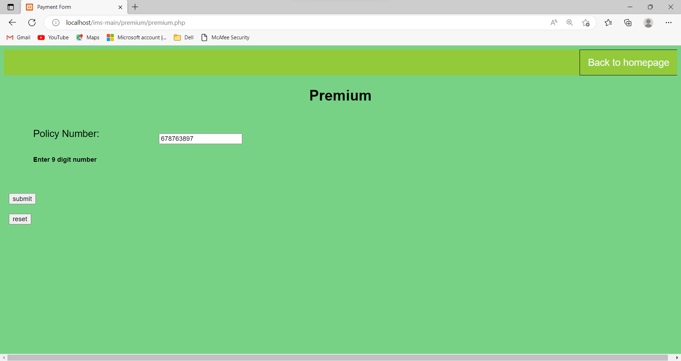

Premiums Data

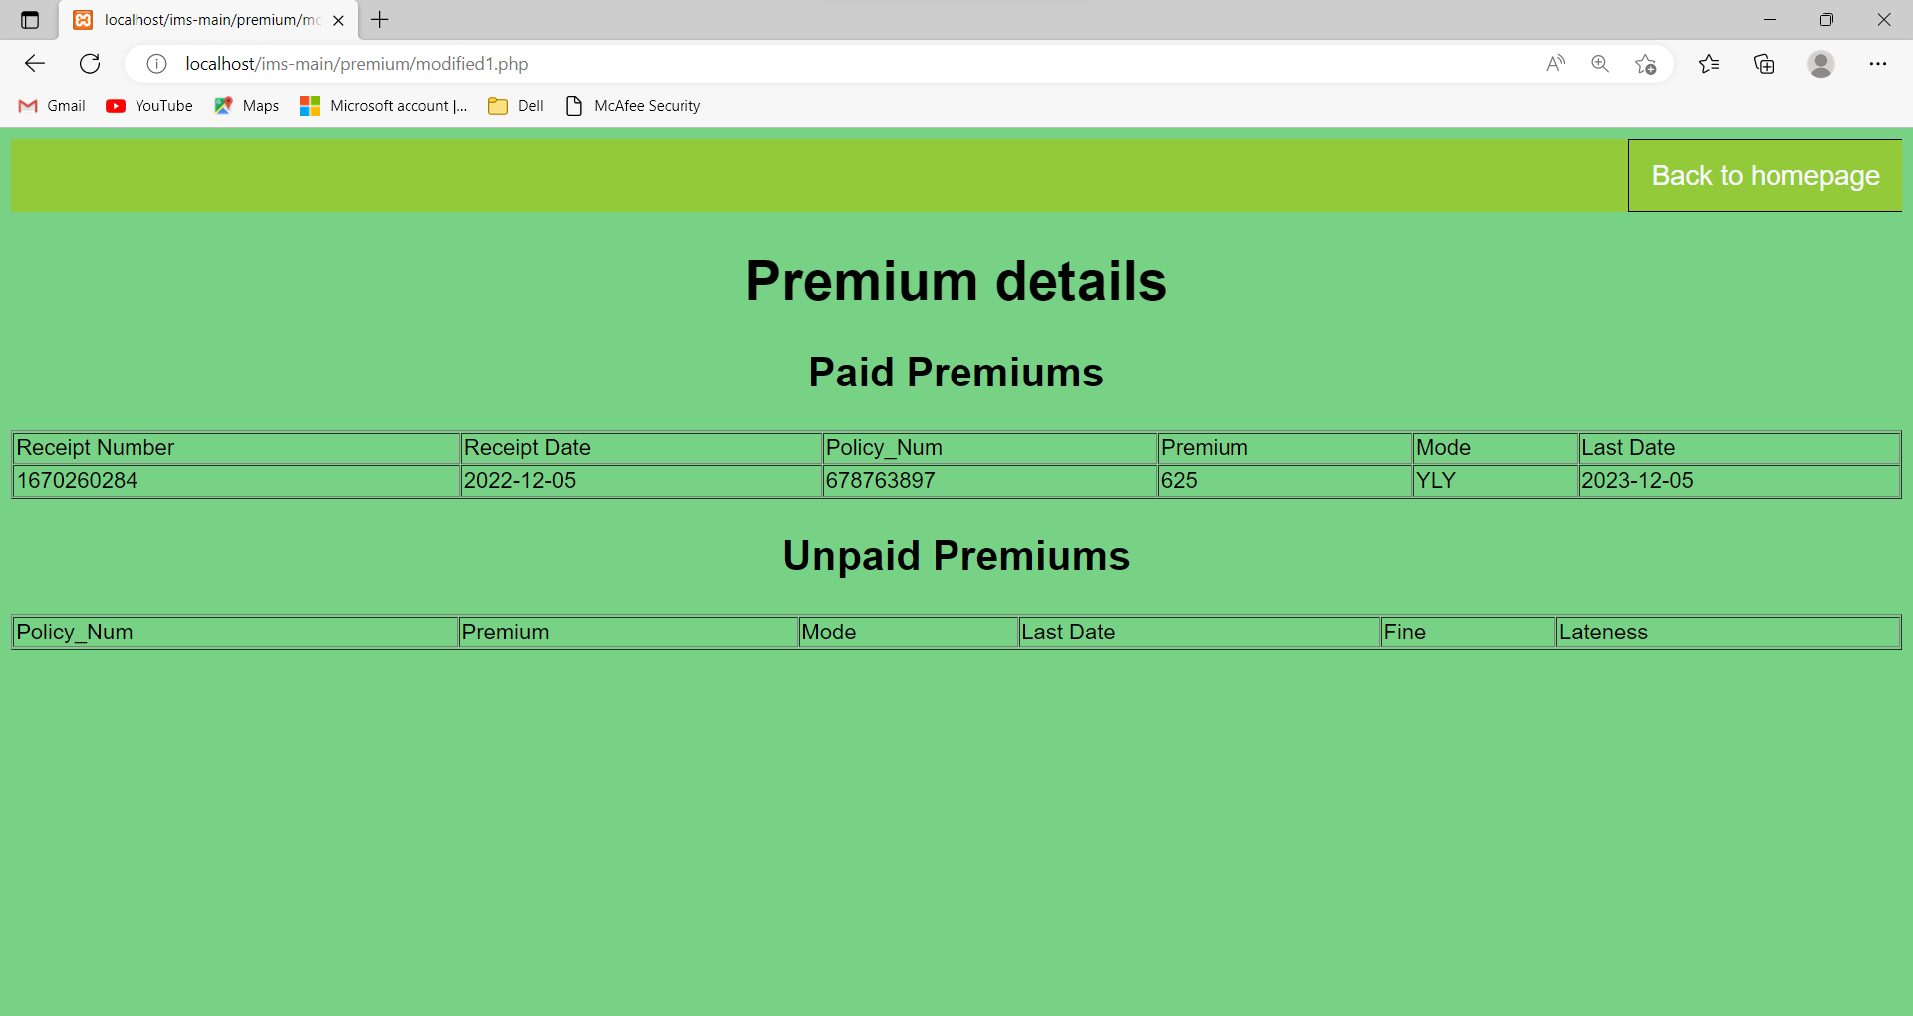

Enquires

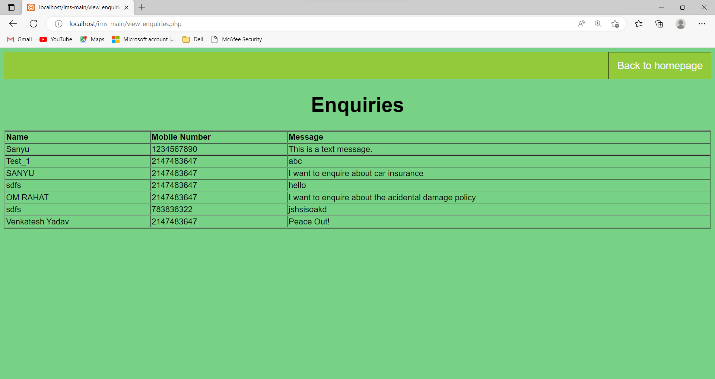

# REPORTS

## Overview Dashboard

This report gives you a holistic view of your products. You’ll get a quick snapshot of orders, sales, and earnings. It’s important to look at this dashboard regularly to monitor your store’s performance.

# ADVANTAGES AND LIMITATIONS

## Advantages

1. User Friendly.
2. Menu Driven Interface.
3. Easily Upgradable.
4. Data Retrieval, Updating, Insertion, and Deletion.
5. System Consistency.
6. Allowing Keyboard Inputs.
7. Taking care of Computing time.
8. Easy Database Handling.

## Limitations

1. No Online Payments.
2. No Search Engine Optimization.
3. No Email Verification during Registration.
4. No Sales Report was Generated.

# FUTURE ENHANCEMENT

The system is designed in such a way that the addition of new modules can be done in a very simple and efficient manner. The future holds a lot to offer to the development and refinement of this project. As proper documentation exists the whole system flow is traceable.

Some likely enhancements could be added in the future to enhance the capability of this system.

We may conclude that this software created will find a good market in the online Supermarket to its maximum extent.

Future Version of this software will include the following:

* Coupons.
* Online Payments.
* Wallets.
* Premium Membership.
* Image and Voice Search.

# BIBLIOGRAPHY

## Book Reference:

1. PHP: THE COMPLETE REFERENCE by Steven Holzner
2. PHP, MySQL & JavaScript All-in-one by Richard Blum

## Web Reference:

* + - * [www.google.com](http://www.google.com/)
      * [www.youtube.com](http://www.youtube.com/)
      * [www.w3schools.com](http://www.w3schools.com/)
      * [www.smartdraw.com](http://www.smartdraw.com/)
      * [www.stakeoverflow.com](http://www.stakeoverflow.com/)
      * [www.fonts.google.com](http://www.fonts.google.com/)
      * [www.fontawesome.com](http://www.fontawesome.com/)
      * [www.icons8.com](http://www.icons8.com/)
      * www.pinterest .com
      * [www.udemy.com](http://www.udemy.com/)